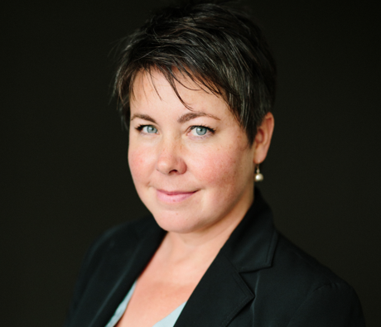
DEFEND DEMOCRACY ACTIVIST TO SPEAK AT
MANISTEE DEMOCRATIC PARTY MONTHLY MEETING
Betsy Coffia, Grand Traverse County Commissioner and Democratic candidate for the new 103rd Michigan State House District will be the featured speaker at the Thursday January 20, 2022 meeting of the Manistee County Democratic Party. Ms. Coffia is the coordinator of the Defund Bergman campaign which serves as a model for campaigns around the state & nation holding members of the January 6th Sedition Caucus accountable for their actions. Under her leadership, Defund Bergman has built an unprecedented coalition of Upper & Lower Peninsula progressive leaders working together across this huge Congressional district. They have succeeded by flooding social media and mailing letters asking corporate donors to stop funding the campaigns of elected officials that continue to spread the Big Lie that the 2020 Presidential election was fraudulent and are making it more difficult for citizens to vote in future free and fair elections. Betsy has also earned a reputation for getting things done for her constituents as a minority member of the contentious Grand Traverse County Board of Commissioners, a group that has drawn national media attention in 2021 due to outrageous right-wing posturing having little to do with meaningful county government issues.
This meeting will be held both in-person and via ZOOM. The meeting will begin at 7PM on Thursday January 20, 2022 at the West Shore Community College building on River Street in downtown Manistee. If you plan to attend in-person, it is requested that you be fully vaccinated and boosted and wear a mask. To obtain a ZOOM link for this meeting please visit the Manistee Democratic Party Website: https://www.manisteecountydemocrats.us

