

**Manistee Celebration fundraiser**

**for Tom Stobie Launch**

**Friday March 21, 5:00 – 7:00 PM $20 suggested donation**

**At the home of Mary Russell, 272 Light House Circle, Manistee**

**EVERYONE IS WELCOME TO ATTEND/DONATIONS OR NOT**

*Party will provide appetizer refreshments*

**CAMPAIGN LAUNCH TOUR**

**THURSDAY MARCH 20**

**Manistee - 11:30am- 12 Noon** The Ramsdell Inn

2nd Floor Lobby Room

399 River Street

COME 15 MINUTES EARLY, grab a rally sign and stand behind Tom as he announces his candidacy for the 101st State House!!! Come and show your support. We need a good crowd for this media event launching Tom’s campaign. Tom will speak and answer questions from the press. Appetizers and coffee from TJ’s will be served.

Tom’s Launch Tour will include similar events in Mason, Benzie and Leelanau counties.

***www.manisteecountydemocrats.us***

*“We’ve got a great candidate in Tom Stobie. He’s a veteran, teacher, coach, and administrator who ended his career as the Superintendent of Frankfort-Elberta Area Schools in Benzie County.*

*Tom will fight back against Ray Franz and the extremist agenda that’s taken over Lansing.”*

*Dan Scripps*

**Monthly Meetings**

**4th Thursday**

**7 pm – 9 pm**

**Dial-a Ride, Manistee**

**includes**

**Guest Speakers**

**Officers**

**Chair**- Peggy Raddatz

peg.raddatz @gmail.com

**V. Chair**-Keith Schearer

**Secretary-** Laurel Mason

[laurele52@charter.net](mailto:laurele52@charter.net)

**Treasurer**-Joanne Collins

[collij1946@yahoo.com](mailto:collij1946@yahoo.com)

**Supporting** **Staff**

Membership Chair

Ellen Somsel

Newsletter Editor

Judy Cunningham

Webmaster and

Social Media Chair

Lee Trucks

#### Quisque:

3

2

#### Feugiat:

### Spring 2013

## ***A Letter***

## ***FROM THE CHAIR***

Dear Fellow Democrats,

Over the last few years, I’ve seen the Michigan I’ve known and love turn into a political nightmare that no way resembles the values of the people who worked so hard to make it great. The mantra on everyone’s lips when we talk about another law passed against women’s health rights, voting rights, environmental conservation, senior pensions, the gutting of our school budgets, access to phone lines etc. etc. etc., is ***we will remember in November.*** But that may be too late.

Really, the time is now. Our candidates will be faced with opposition so well funded by special interest groups, Democrats will be greatly tested to counter with ads stating the truth. Be prepared for sensational, half-truth television ads funded by the extremist-minded Koch Brothers and all those shiny, postal cards to fill your mailbox this fall.

Our strength is in our people. We need you to get involved now. Then you can help us identify each and every Democrat in the County and make sure they vote. They can vote by absentee ballot, or we can help get them to the polls in November.

The first step we ask of you is to join the Local Party. A membership form is included in this mailing. Then go the State Party Website where you can join the MDP for free, so you can get breaking news on the state level.

Please find time to participate in upcoming Events. We have a Petition Day of Action on March 22 at Dial A Ride from Noon to 4. Exercise your Voting Rights at the base level and sign petitions.

Lastly, support Democratic Candidates. We have had outstanding people step forward to run for office. After you donate money, donate your time.

Manistee County Dems will have an office open for the fall election cycle. Staff volunteers will be needed. Say yes, when you are called to serve.

Working together, we can bring back Michigan values to the Great Lake State we all love, by supporting and promoting candidates that also hold these time-tested Michigan values.

Peggy Raddatz,

Chair

Manistee County Democrats

 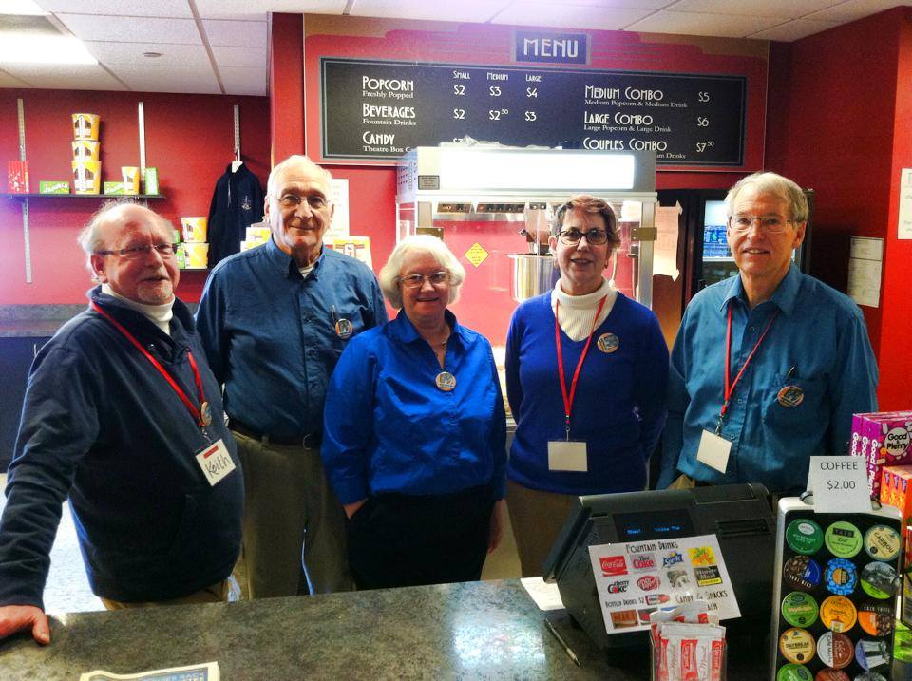

We were sad to hear that Karl Waitner Jr. announced recently that he will be stepping down from his post as the Manistee County 5th District Commissioner seat after accepting employment in another community. However, he has endorsed a candidate as his replacement, Karl Waitner, Sr.

“I strongly endorse my father for the position,” Waitner Jr. said. “I get a lot of my views and thought processes from him and from a personal, political and professional standpoint, I think it’d be great to see the father replace the son.”

Waitner Sr. served as a commissioner for four years in the early 1990s, on Manistee Area Public Schools board for eight years, the Manistee County Planning Commission for about 12 years and was chair for most of that time, and the Manistee County Blacker Airport Authority for four years.

“I’m not new to the county’s political arena,” Karl Sr. said. “I believe I have something to contribute. I want to do what’s best for the residents. You have to look at each issue and determine what’s best for the people.”

District 5 consists of the part of Onekama Township that is the Village of Onekama, all of the township lying south of Eight Mile Road and the portion of the township lying west of M-22 and north of Portage Lake; and all of Manistee Township, except the Village of Eastlake.

The following commissioners will be making this decision. Contact them and tell them who you, the voter, want to replace Karl Waitner, Jr.

**MANISTEE COUNTY BOARD MEMBERS:**

**District 1** Ken Hilliard, P.O. Box 247, Onekama, MI  49675 (231) 510-4828;

e-mail: [kjk5106@gmail.com](mailto:kjk5106@gmail.com)

**District 2**  Richard Schmidt 11013 Healy Lake Road, Kaleva, MI  49645 (231) 970-0597; e-mail: [rschmidt51@hotmail.com](mailto:rschmidt51@hotmail.com)

**District 3**  Brook Shafer 18 S. Moss Road, Wellston, MI  49689 (231) 848-4877; e-mail: [chiltonb@kaltelnet.net](mailto:chiltonb@kaltelnet.net)

**District 4** Mark Bergstrom 1224 Critter Trail, Manistee, MI 49660 (231) 398-0742; e-mail: [mabergstrom@charter.net](mailto:mabergstrom@charter.net)

**District 6** Jim Krolczyk, 434 Elm Street, Manistee, MI  49660 (231) 723-0116; e-mail: [trombonemsu@yahoo.com](mailto:trombonemsu@yahoo.com)

**District 7**  Alan Marshall 914 Vine Street, Manistee, MI 49660 (231) 510-2421; e-mail: [awmarshall@hotmail.com](mailto:awmarshall@hotmail.com)

CALL TO ACTION!!

ALL RESIDENTS OF THE 5TH DISTRICT

Who do you, as a voter, want to replace

KARL WAITNER JR.?

Karl Jr. endorses his dad, Karl Sr. for his position

* **Blossom Boulevard – June 21-Aug. 16**

*Help beautify US 31 through the city by planting and watering petunias*

Priorities for 2014 are fundraising for scholarship/student support.

**If you want to help: contact....**       Jo R. Hall 231-723-0125

[jo.hall@sbcglobal.net](mailto:jo.hall@sbcglobal.net)

Check out the Blue Tigers Volunteer sign up page on ManisteeCountyDemocrats.us

In Saturday’s Manistee News Advocate, the editorial stated: “America is a country that was built on having choices at the ballot box, and we need to see more of that at the local level. Giving the voters a choice is what democracy is all about, and we hope the residents of the 5th District will get the opportunity to exercise those rights in November”.

Although the editorial referred to the appointment of a replacement Commissioner on the County Board, it also rings true for all the open seats this coming November (whoever is appointed by the County Commissioners to replace Karl Waitner, Jr. may choose to run for office in November, 2014 for the seat).

The Manistee County Democratic Party is participating with the ***Mark Schauer*** for Governor, ***Gary Peters*** for U.S. Senate and General ***Jerry Cannon*** for Congress campaigns to hold a PETITION DAY OF ACTION.

***Come and join other Democrats, Sign the petitions and help put our candidates on the BALLOT!!!***

**SATURDAY: MARCH 22, 2014**

**DIAL-A-RIDE BUILDING**

**101 MEMORIAL DRIVE**

**12:00 NOON – 4:00 PM.**

Blue Tiger Democrats

**VOLUNTEER OPPORTUNITIES**

* **Vogue Theater - April 19-20 and May 17-18**

*Help support this beautiful community theater with other Democrats on the Blue Tigers Team Vogue. Duties include concessions, ticket takers and ushers.*

*No pre-training necessary.*

**PETITION DAY OF ACTION**